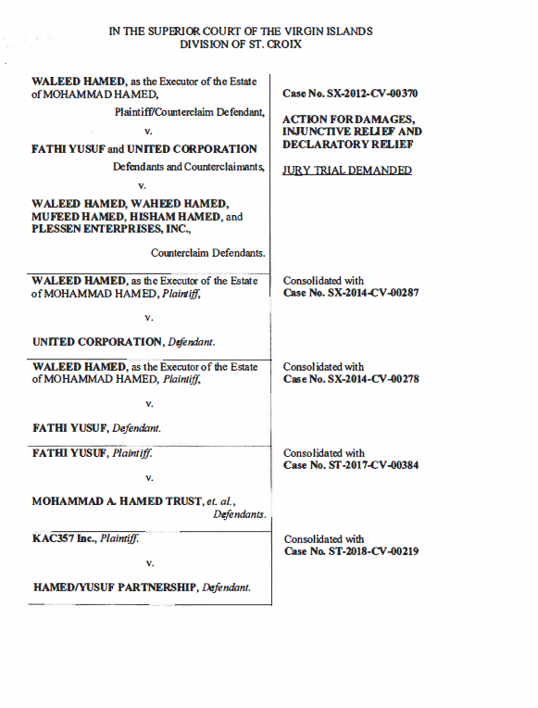Hamed v. Yusuf, et al. Case No, SX-2012-CV-370
Order
Page 2 of 2

ORDER

THIS MATTER is before the Court on the Motion of Carl J. Hartmann, co-counsel for the Plaintiff to withdraw as counsel--effective October 1, 2024. The premises considered, the Court will grant the Motion.

ORDERED that Plaintiff's co-counsel’s motion to withdraw a counsel is GRANTED effective October 1, 2024.

DATED: ___________________, 2024. _____________________________
DOUGLAS A. BRADY, JUDGE

ARREST: TAMARA CHARLES
Clerk of the Court

By:_________________________
Court Clerk

